Think Python book question note

On Page 53, snippet as below

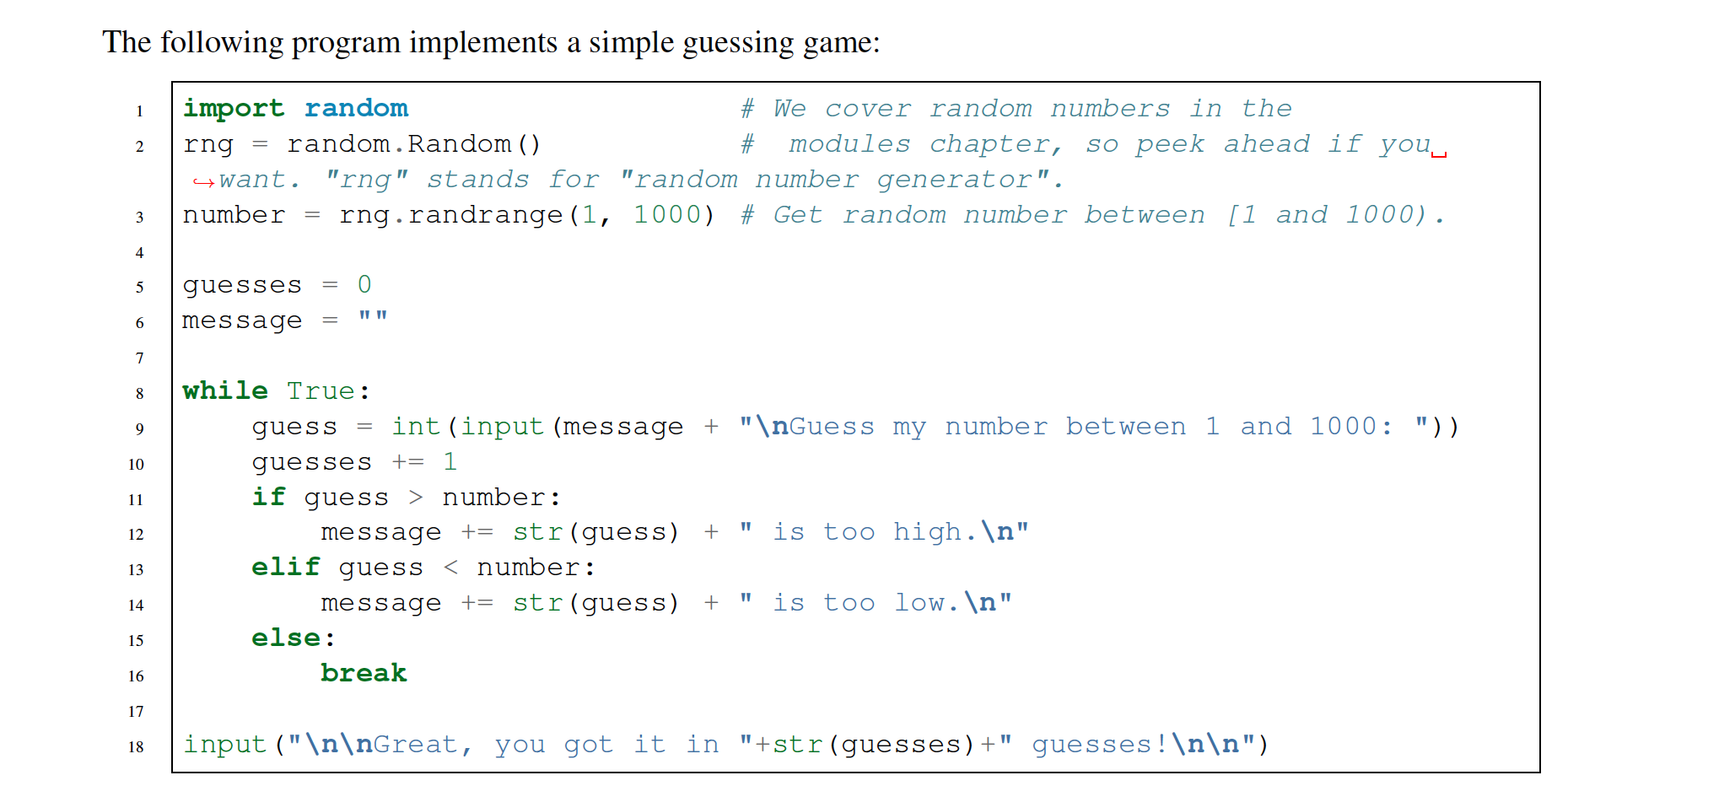

When run the code, every time user guessing, program would print out message, but there is no print function. How does that work?

On page 188:

* How to construct test class
* Exercise 5 -- Collision function

On page 183 – exercise 6

Hackerrank:

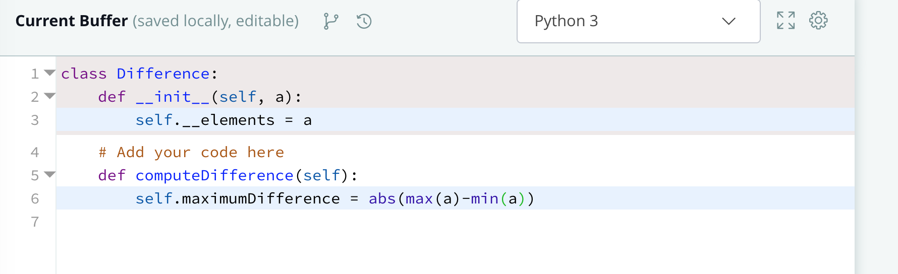

claim the new attribute of a class not in __init__ but in following method, legal?